Welcome to the second issue of the Friends of the Emm Brook Newsletter. We hope you enjoyed the last one! Since then a lot has been going on and some new dates are shown below.

We hope that those of you who joined us on the first walk on 23rd January enjoyed it and will tell your friends and neighbours to come along to our next one. Here are a couple of pictures from the first walk.
The walk proved to be a real eye opener to many, if not most, of the walkers. The young and not so young enjoyed the winter sun and views at leisure and were pleasantly surprised what lies just round the corner from Tescos!
We have now planned another riverside walk, which will be on 20th March at Dinton Pastures, as the last one was such a success (see below).
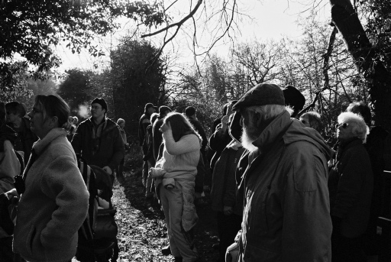
Our next event is the Litter Pick on 27th February, details below. Please wear boots or strong shoes and bring thick garden gloves if possible. We will be providing “pickers”, sacks and a safety talk.
We now have a map of the Emm Brook that has been drawn by Cyril Fuller (to avoid Copyright issues). A copy of the map is attached to this newsletter.
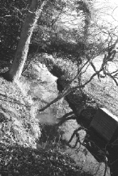
Event | Date & Time | Location / Contact
Litter Pick | Sunday 27 February  10.30am – 12.30pm | Safeway, Woosehill - near the doctor’s surgery.  Sue Farrington (978 2371)
Riverside Walk | Sunday 20 March  10.30am – 12noon | Dinton Pastures overflow car park – main entrance and immediately turn left .  Cyril Fuller (979 1415)
Easter Egg Hunt | Saturday 26 March  2pm - 4pm | see map overleaf  Natash Bright-Thomas (07092 075753)
Public Meeting to present the Management Strategy | Monday 16 May  7.30pm –9.30pm | Rose Street Methodist Church  Sue Farrington (978 2371)

Monitoring
The wildlife monitoring group plans to carry out a breeding bird survey along the Emm Brook in Spring/Summer 2005, as an early stage monitoring activity. Analysis of the results from this and subsequent years will provide information on the variety of species present, the relative abundance of species in differing habitats, responses of bird numbers to habitat management actions, and long-term monitoring of bird populations.
The survey will follow the course of the Emm Brook through Wokingham, classifying the habitat types and counting the number of birds in short sections of the survey route. Each section is surveyed in three visits between mid-April and mid-June and a number of participants will be required. Familiarity with common birds is preferable in making a thorough survey. Anyone interested in participating in the survey should contact Mike Saynor on 978 1804.
Nature Corner - Waxwings
Wokingham Riverside was recently visited by a flock of Waxwings, peaking at 120 on Sunday 31st January. They made short work of the rowan berries in at least one front garden, and a number of Wokingham residents came to see them, together with birders from as far as Slough. Waxwings are related to starlings, but grey-buff in colour, equipped with a long crest, yellow tail-tip, neat black mask and bib and named for the red waxy appendages to some of the flight feathers. They are annual winter visitors to the UK, however this year they are present in exceptional numbers due to failure of the berry crop in Scandinavia.

Locally, Bracknell has proved to be reliable for Waxwings for many years since, like most new towns, it has been amply furnished with berry-bearing rowans; this year the flock reached 300 in mid-January and it is probably some of these birds dispersing that have been present around Wokingham.

Kingfishers

The Kingfisher is one of the bird highlights of the Emm Brook and nationally is an "amber list" species of medium conservation concern. Reading and Newbury District Ornithological Clubs are organising a survey of Kingfishers in Berkshire and would like to receive sightings of Kingfishers in the county up until the end of July. If you see Kingfishers along the Emm Brook, or anywhere else, then please note the time, date and location (preferably with grid reference), how many birds were seen (and optionally any interesting behaviour) and then send the information to Mike Saynor or Paul Bright-Thomas (emm-monitoring@emmbrook.org.uk), who will collate the records and forward them on to the survey. For differences between male and female Kingfishers - you have to see them pretty clearly - see a good field guide.

The Easter Egg Hunt

Saturday 26th March 2005 from 2pm to 4pm. The hunt will take place along the Woosehill Lane bank of the Emm Brook. The area can be accessed by footpaths from Woosehill Lane and from Arthur Road. For those driving, parking is on neighbouring residential roads – so please be considerate to the residents. The hunt will be for a number of hidden questions about the Emm Brook and FOTEB (all answers are in the first 2 newsletters). Entrants must be under 18 and be accompanied by an adult. The area chosen is by the river and is open to public access, which includes dogs and bikes – please be aware of this. 1 Egg per entrant. Entrants do so entirely at their own risk. Egg packaging must be disposed of properly. Eggs may contain nuts.
To contact us :

Sue Farrington (Chairman) 978 2371

Jean Vaughan (Secretary) 979 0538

Newsletter 07092 075753 or
newsletter@emmbrook.org.uk

Mike Saynor (Monitoring) 978 1804

Conservation
Preparation of a Management Strategy for the whole of the Emm Brook is the first major task to carry out. It will start as a high level document to identify the threats and concerns for the brook and will identify manageable sections that will be the subject of more detailed plans. We plan to have this ready for a wider audience to contribute views, ideas and wishes in May.

Until this document has been agreed it is inappropriate to carry out much active work in and around the Brook other than non-invasive tasks such as litter clearance.

Photographs

We would be very pleased to receive any photographs of the Brook and surrounding areas that shows off the plant, bird and other wildlife. With your permission we will then add some of them to our web site or include in display material and later newsletters. Please send them to vicechair@emmbrook.org.uk or Jack Earnshaw 30 Copse Drive, Wokingham RG41 1LX.

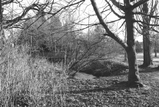

Next Newsletter

We plan to have our next newsletter out in April. Any articles, sighting or ideas are welcomed. Please send them on to us at newsletter@emmbrook.org.uk or telephone 07092 075753.

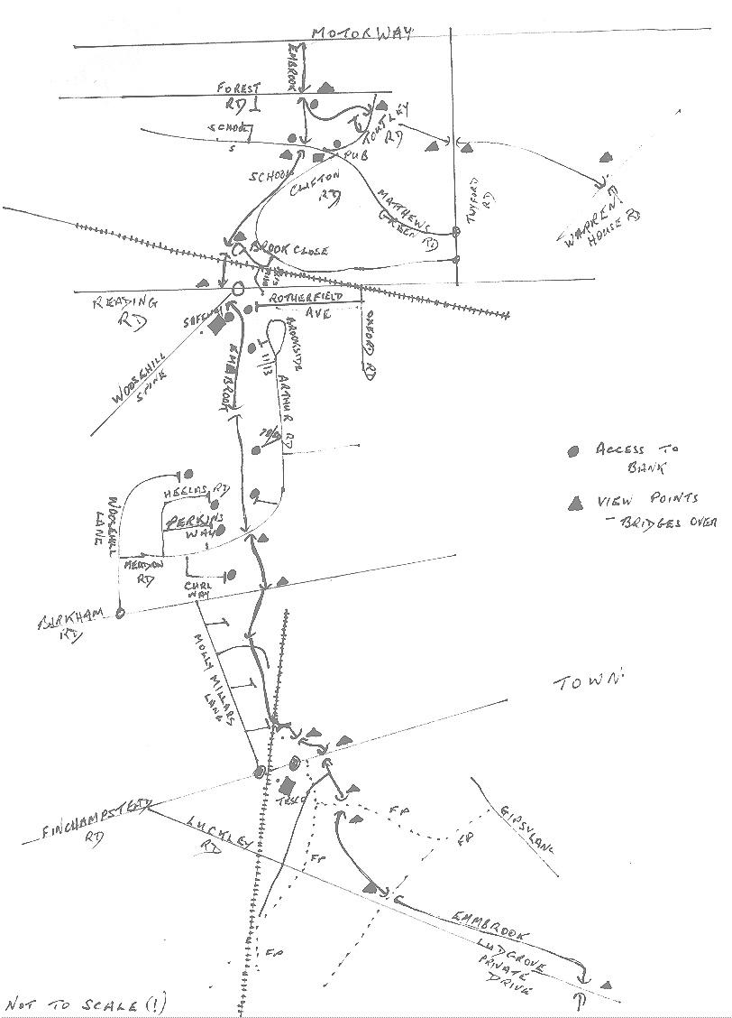
Easter Egg Hunt

Sketch Map of the Emm Brook – South of the Motorway

